|  |  |  |
| --- | --- | --- |
| **G:\Charusat Logo.jpg** | **International Radiology Day 2017**  Radiation awareness: we care for you  8th November 2017 | **G:\Logo CIPS (1).jpg** |

Event Report

Our International Radiology day event was organized on 8th November 2017. The event was planned with a theme “Radiation awareness: we care for you” to create awareness and knowledge among students and public about the effects of radiation. This event basically aimed to aware students and general public about the measures and precautions required to avoid unnecessary exposure to radiation while working or visiting Radiology department such as X ray, CT scan, Mammography, Ultrasound etc. The event was organized by the Department of Medical Imaging and Radiology Technology, Charotar Institute of Paramedical Sciences (CIPS), Charotar University of Science and Technology (CHARUSAT).

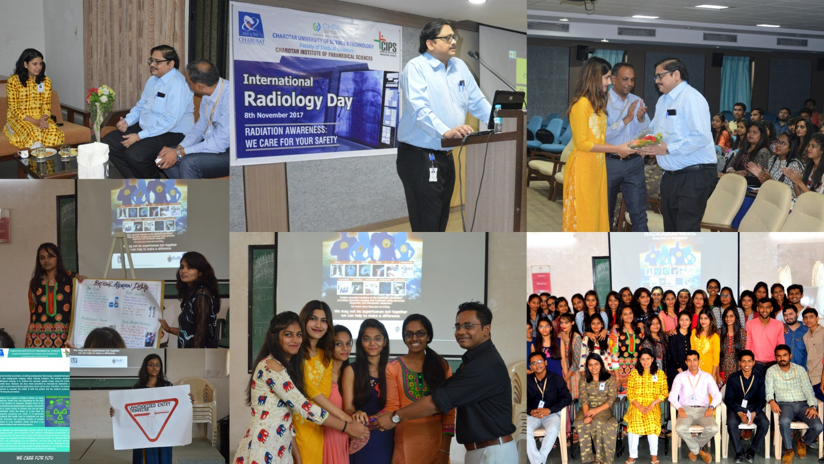

**The event enclosed:**

1. Guest speaker talk on CT and MRI safety in Radiology department by Dr. (prof.) Deepak V Mehta, Dept. of Radio Diagnosis, Karamsad Medical College.

2. Poster presentation on Personal Radiation Dosimetry, Precautions to be followed for Female patients during their clinical visits to radiology department by MRIT 3rd semester students.

3. Radiation awareness symbol presentation by MRIT 1st semester students.

4. Radiation awareness template preparation and distribution by Ms. Dolly Sharma, Assistant professor, MRIT Dept., CIPS. More than 100 participants including staffs and students have participated in this program.